Ashoka

The non-profit, non-governmental organization Ashoka, over the last 35 years is the leading global network of social entrepreneurs. Todays the largest global network of social entrepreneurs - men and women who put in practice their innovative ideas to solve systemic social problems.
Based on the principle that the most effective way of promoting social change is to invest in social entrepreneurs with innovative solutions, sustainable and applicable in national and international level. To date, Ashoka has supported and integrated them into the global network of 3,146 leading social entrepreneurs (Ashoka Fellows) including two holders of the Nobel Peace prize (Kailash Satyarthi and Mohammad Yunus).
The network of the Ashoka Fellows is implementing system-changing solutions to human and environmental problems in 89 countries.

Ashoka was founded in 1980 by Bill Drayton and was named after Ashoka, the Indian leader who unified India in the 3rd century BC renouncing violence and dedicating his life to social welfare and economic development. Its symbol is the oak, symbolizing commitment and contribution of the organization in strengthening the social entrepreneurship.
The European family of Ashoka only recently started its activities in Greece, thanks to the support of the The Hellenic Initiative and the Robert Bosch Foundation (Robert Bosch Stiftung).
Our vision is a world that responds quickly and effectively to social challenges, and where each individual has the freedom, confidence and societal support to address any social problem and drive change.
Our mission is to shape a global, productive and highly effective sector of civil society - a sector that will contribute to the development of social entrepreneurship and will encourage citizens all over the world to think and act as agents of change - Everyone a Changemaker ™ .
Our goal is to contribute in finding effective and long-lasting solutions for some of the most urgent social problems, through the support of innovative social entrepreneurs.

To this end, we work on three levels:
1. Investing in leading social entrepreneurs in order to strengthen their social impact on a national and global scale,
2. Contributing in building alliances of social entrepreneurs with other actors of society, both of public and private sector, in order to solve social problems on a large scale,
3. Supporting the younger generations - from childhood to adulthood – creating awareness towards social problems and supporting the development of the skills required, in order for them to take initiatives for the prevention and resolution of social problems.
Learn more about Ashoka Greece: http://greece.ashoka.org/

Actions in Greece
1.
Impact Program: strengthening the social impact of selected Greek initiatives
The Impact Program is looking for people who contribute with their ideas and their work in solving social problems, such as the promotion of health, education, employment, migration, etc. and gives them the necessary expertise and resources to continue and strengthen their efforts. The first Impact Program was held in France in 2007, followed by other European countries and this year was held for the first time in Greece from Ashoka in cooperation with The People's Trust and Accenture.
The initiatives Paths of Greece, Sarantaporo.gr, Recycle at source, Startup boat, ALMA, SciCo and Bloode participated in the program that lasted for six months. During this time, participants had the opportunity to shape appropriately their business plan, ensuring its sustainability, and adopt parallel development strategies to multiply their positive impact on society. Partners in the Impact Program were Accenture and The People's Trust. Accenture offered seven senior executives, who followed, on a weekly basis, the progress of the initiatives, providing advice and guidance. The People's Trust recognizes the importance of initiatives with a social purpose and aims in strengthening the entrepreneurship in Greece. Therefore, The People's Trust provided to the three social entrepreneurs, whose project best met the criteria of the relevant committee, a financial support of € 8.000 in order to further support their business steps. This financial aid is linked to the provision of consultancy services from Accenture.
For more information on the event, visit: www.ashoka-impact.gr
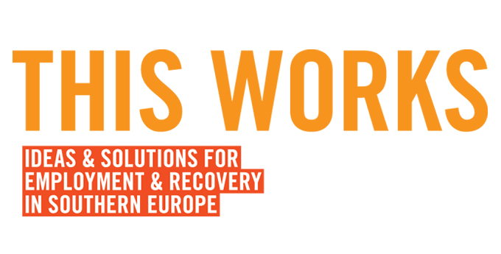
2. THIS WORKS. Ideas and Solutions for Employment and Recovery in Southern Europe, is an initiative of Ashoka in cooperation with the Robert Bosch Foundation and a set of partners, and began in 2014 to strengthen social innovation in the field of unemployment in Greece, Italy and Spain. The Hellenic Initiative is the main partner for Greece. The program aims to highlight and bring in these countries, the most effective solutions from Ashoka’s network which can create change and build a new ecosystem for social entrepreneurship and employment in Southern Europe.
Visit http://thisworks.ashoka.org/ website to learn more about the program!

